4.0 Software Development Plan

4.1 Plan Introduction

Our project is called *Impossible3*, a dungeon crawler with graphics powered by Unity. The project will make use of skills garnered by our team members’ over the course of their career at Loyola Marymount University. The team will meet regularly over the course of the semester to discuss logistics and design decisions.

The team plans to complete the movement and obstacle-generation systems by Week 7, the clock system by Week 8, and a working first-level dungeon by Week 12.

4.1.1 Project Deliverables

Project Proposal: A description of the project to our class and a justification for its existence. This was given on Week 3.

Needs Analysis: Non-detailed description of requirements that our final product must satisfy, this was never turned in, it was scrapped in favor of the RD.

Requirements Document: A description of the requirements that our product must satisfy, we wrote this to define our minimum viable product. This was turned in on Week 5.

Preliminary Schedule: Preliminary work schedule with expected completion dates in relation to our game. This was completed on Week 5.

Software Development Plan: A detailed plan for the completion of our product, this document includes the organization of our team and a summary of the previous deliverables.

Architectural Design Doc: Describes the code of our project in detail.

Detailed Design Spec: Like the ADD, but, with more details.

Configuration Management Plan: Details how we will periodically “freeze” iterations of the project in order to store them as working iterations (backups).

Testing and Integration Plan: How we plan to test our minimum viable product, e.g. will we use short unit tests (snippets of code), will we compile the game and play it? And so on and so forth.

4.2 Project Resources

To complete our project and deliver it in it’s entirety, we need our own computers to code on and install Unity, the game engine software that we will be making our game in.

4.2.1 Hardware Resources

|  |  |  |
| --- | --- | --- |
|  | Development | Execution |
| **PC**  OS: Windows 7, 8, 10  GPU: Graphics Card  CPU: SSE2 Instruction Set support | X  X | X  X  X |
| **iOS**  OS: Mac OS X 10.9.4 with Xcode 7.0 or higher  GPU: Graphics Card | X  X | X  X |

4.2.2 Software Resources

|  |  |  |
| --- | --- | --- |
|  | Development | Execution |
| **PC**  GPU: DirectX 9 with shader model 3.0 or DirectX 11 with feature level 9.3 capabilities  Unity 5.4  Git | X  X  X | X |
| **iOS**  OS: Xcode 7.0 or higher  Unity 5.4  Git | X  X  X | X |

4.3 Project Organization

In *Impossible3*, we have six members: Justin Sanny, Nick Soffa, Flanders Lorton,

Ronald Uy, James Yen, and Erik Tsai.

We are separated into two 3-member groups: Frontend and Backend.

The Frontend team consists of Flanders Lorton, Erik Tsai, and Ronald Uy.

The Frontend team’s roles are Graphic Designer, GUI Designer, Interface Manager, and Sprites Artist.

The Backend team consists of Justin Sanny, Nick Soffa, and James Yen.

The Backend team’s roles are Character Designer, Combat Designer, Ability Author, Balance Testers, Movement and Grid Designer, and authors of Lore.

Roles:

* Graphic Designer:
  + Creates in-game graphics.
* GUI Designer:
  + Creates general combat interface.
* Interface Manager:
  + Designs character menus as well as in-game interfaces such as the Menu Screen.
* Sprites Artist:
  + Draws and implements sprites for the general interface and old women.
* Character Designer:
  + Designs and implements character based on class or type.
* Combat Designer:
  + Develops combat between the AI and player.
* Ability Author:
  + Writes and creates abilities based on the character.
* Balance Testers:
  + Balance and check the game for bugs.
* Movement and Grid Designer:
  + Designs movement system and grid base.
* Lore Author:
  + Originates game story and plot.

Frontend Team:

* Flanders Lorton:
  + Interface Manager
  + Graphic Designer
  + Character Designer
  + Ability Author
* Erik Tsai:
  + Interface Manager
* Ronald Uy:
  + Graphic Designer
  + Interface Designer
  + Character Designer

Backend Team:

* Justin Sanny:
  + Character Designer
  + Ability Author
  + Combat Designer
  + Lore Author
  + Balance Tester
* Nick Soffa:
  + Movement and Grid Designer
  + Lore Author
  + Combat Designer
* James Yen:
  + Character Designer
  + Balance Designer
  + Combat Designer

4.4 Project Schedule

4.4.1 PERT / GANTT Chart

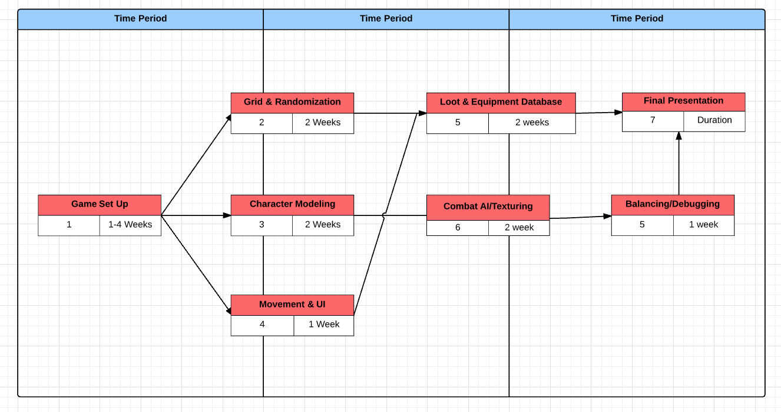  
 4.4.2 Task / Resource Table

